Rethinking Pakistan’s Development Strategy
Naved Hamid∗

Abstract
The objective of this paper is to set out the key components of a development strategy for Pakistan. A fundamental premise of our analysis is that the world economic environment is changing dramatically and a development strategy today must position itself to take advantage of the changes taking place. The paper is divided into five sections: First, we provide a brief review of Pakistan’s experience with development strategies so far. Next, we discuss the changes that have occurred, or are taking place in the global economy, which have strategic relevance for Pakistan. In the third section we look at the current situation in Pakistan with regard to the potential drivers of growth, based on the earlier discussion of the global developments. In the final section key elements of an alternative development strategy for Pakistan are outlined.
JEL Classification: O11, O20, O40
Keywords: Development Strategy, Growth, Globalization
I. Evolution of Development Strategy in Pakistan – A Brief Economic History
Like most developing countries, in the 1950s and 1960s, Pakistan pursued a development strategy aimed at promoting industrialization through import substitution policies and planning, with the state playing the leading role. However, unlike many other countries public enterprises in the manufacturing sector in Pakistan were set up to show the way to the private sector and many were subsequently sold to private entrepreneurs. Also, manufactured exports were encouraged through a system of multiple exchange rates. Pakistan’s development strategy was clearly articulated by Mahbub-ul-Haq (1966), Pakistan’s Chief Economist in the 1960s, in his seminal work “The Strategy of Economic Planning” and made operational through the Second and Third Five Year Plans. The strategy was extremely successful in accelerating economic growth and Pakistan was seen as one of the few development success stories of the 1960s.
In the 1970s, during the Bhutto period (1972-1977), there was a reversal of the private sector led growth strategy. Pakistan shifted to the Indian development strategy, i.e., state led, heavy industry based industrialization strategy. Engineering, cement, oil refineries, chemicals and many other industries, together with shipping, banking, life insurance and power utilities were nationalized. Export trade in rice and cotton was made a state monopoly. An ambitious public sector investment program in heavy industry was launched. The first oil crises, together with the massive public investment program and the large increase in other development expenditures led to ballooning fiscal and current account deficits. The nationalizations led to a drying up private investment and economic growth slowed sharply, and so Pakistan’s first growth episode came to an end.
The Zia government that took power following a military coup in 1977 started a gradual process of reversing policies of the previous six years. The development strategy of this period can best be described as a mixed economy, import substitution strategy. Industries were slowly de-nationalized, but the massive public sector investment program in heavy industry was continued. There was some trade liberalization, but the investment licensing system was retained and the state’s monopoly on cotton exports was used to tax cotton production and to provide huge incentives to the textile spinning industry. In the case of sugar, restrictions on imports and zoning regulations for sugar mills were continued and provided excessive profits in the sugar industry. State ownership of the banking sector was maintained and used to channel funds at low interest rates to cronies.
However, because of the Afghan war there were large capital inflows in the form of assistance from the U.S and International Financial Institutions. These inflows were supplemented by a sharp increase in workers’ remittances. As a result in the 1980s, Pakistan experienced rapid economic growth. However, the economic policies gave rise to an inefficient and unbalanced industrial sector. This consisted of a large and inefficient state owned basic industries sector (steel, engineering, fertilizers, cement, etc.) and an equally inefficient private large scale manufacturing sector concentrated in the rapidly expanding textiles and sugar industries. Growth was also not sustainable, as it was accompanied by growing fiscal and current account deficits financed by domestic borrowing and large inflows of foreign assistance. With the end of the Afghan war, capital inflows declined giving rise to a balance of payments crises in the late 1980s which brought Pakistan’s second growth episode to an end.
In the post 1988 period, Pakistan adopted the policy package associated with what is popularity known as, the “Washington Consensus”. First, the democratic governments from 1988 to 1999, and subsequently the Musharraf Government implemented widespread policy reforms including privatization, investment deregulation, trade liberalization, financial liberalization and tax reforms. Also since the governments during this period found it difficult to maintain fiscal discipline, they were forced to implement stabilization programs from time to time under the tutelage of the IMF. Thus in the last two decades Pakistan has experienced “Stop-go” growth, with the longest expansion being from 2003 to 2008.
In period 1988 to 1998, despite many changes of Government, there was a basic continuity of policies. However, this set of policies cannot be said to constitute development strategy. The assumption seems to have been that these policies would somehow put the country on a high and sustained growth path. Unfortunately, as was the experience of many developing countries in 1990s, they did not. One of the lessons of 1990s is that countries need to pursue growth strategies, not just stabilization and efficiency gains (World Bank, 2005; Rodrik, 2006).
II. Development Strategy in a Changing World
For most people, development strategy is synonymous with industrialization strategy. This is not surprising, historically; the way to economic development has been through industrialization. Both import substitution strategies, popular in the 1950s and 1960s, and export-oriented growth strategies advocated in the 1980s and 1990s were industrialization strategies. Based on historical experience, it is generally accepted that there are three stages of development, i.e., the traditional agriculture stage, followed by the manufacturing or industrial stage, and finally the “post-industrial” or the services stage. Within the manufacturing stage, there is also supposed to be a certain order with textiles and light consumer industry being the starting point (Rostow, 1960). Thus, if a country does not follow this ‘natural progression’ in its development process, economists talk of it ‘skipping a stage’ rather disapprovingly.
In my view in this era of globalization and emerging new technologies, there is a need to de-link development strategy from industrialization strategy. In an earlier paper, I had argued that exports of Information Technology (IT) and IT Enabled Services (ITES) could play a role in accelerating and sustaining high growth in South Asia (Hamid 2007). Here, I would like to propose that, in the case of Pakistan, the development strategy should be one that builds on forces that have the greatest potential to generate growth in the future. I believe there are a number of such drivers of growth available for Pakistan. In identifying these drivers there are three considerations: First, they should be aligned with the changing global realities and the future world growth trends; Second, they must have extensive potential linkages with the rest of the economy and thus be able to drive change in other sectors as well; And third, Pakistan, should have a competitive advantage and an existing base in the selected growth areas.
The most powerful force that is shaping the new realities and driving the world trends is globalization. Globalization has many dimensions and impacts, but here I would like to focus on international capital flows and trade. Private capital flows to developing countries are now far larger than official development assistance. Foreign direct investment (FDI) in developing countries has become a major determinant of successful economic performance. It has been the key to the East Asian success story, with the exception of Korea and Taiwan. FDI has not only provided capital, but it has been the means through which production in these countries has become part of the international supply chains. The resulting access and exposure to technology, management and markets has allowed the forces of change to spread from the export sector in the country concerned to rest of the economy. FDI from industrialized countries, particularly Japan, played a crucial role in the success of export-oriented growth policies of the East and Southeast Asian counties. However, now FDI from developing countries such as China and India is gaining importance. Thus, Pakistan’s development strategy must aim to take advantage of these trends and use FDI, particularly from China and India, to hook Pakistani producers into international networks and supply chains. As discussed below, FDI from India could be especially important for the IT Sector.
The other driving element in globalization has been trade. Falling trade barriers and continuous reduction in transport and communication costs led to the shift of labor-intensive manufacturing industry from developed countries to developing countries. Improvements in telecommunications, information technology and logistics facilitated the growth of intra-industry trade. This resulted in further division of labor in manufacturing and the development of sophisticated global supply chains and acceleration in the transfer of labor intensive manufacturing tasks and activities within each industry to the developing countries. Benefiting from this powerful force of international division of labor in manufacturing, East and Southeast Asian countries have achieved sustained growth rates never seen before. The export oriented growth phenomenon spread from Japan to the four Asian Tigers (Korea, Taiwan, Hong Kong and Singapore) to the Southeast Asian three (Malaysia, Thailand and Indonesia) to China and Vietnam in what has been referred to as the “Flying Geese” model. The rise of China as the industrial workshop to the world may be the culmination of this process. Given the size of China, and the fact that any spillovers from it are likely to be first taken up by countries in its neighborhood (i.e. Indonesia, Vietnam, Cambodia, etc.), the scope for a development strategy for Pakistan based on manufactured exports is limited. Expansion of manufactured exports will be important, but in my view it is unlikely to be the driver of growth for Pakistan, with its population of over 160 million.
The revolution in information and communication technology (ICT) has taken globalization to a higher level. Just as declining transport and communication costs facilitated the move of labor-intensive manufacturing industry to the developing countries in the second half of the 20th century, the ICT revolution has resulted in outsourcing of labor-intensive digital services such as call centers, data entry and transcription services to the developing countries like India. As the capability of the offshore services-export sector in developing countries has improved, higher value added tasks in the fields of engineering, architecture, accounting and health services have also begun to move offshore. Traditionally economists have categorized goods as tradables and services as non-tradables. However, because of the ICT revolution this distinction is no longer valid. With computing power and storage capacity expanding exponentially and the variable cost of digital telecommunication approaching zero, the scope for international division of labor in the services sector will continue to grow.
Thus the scope for accelerating export earnings growth for a country which succeeds in building a competitive IT and ITES export sector is considerable. In India, for example, earnings from IT and ITES exports have been growing by about 30% per annum and are now in the neighborhood of $50 billion. In addition, in India the expanding IT export sector has had a dynamic impact on the whole economy by improving management capabilities and developing entrepreneurs with accumulated capital which they are investing in, and transforming, other sectors of the economy. Thus for Pakistan, having missed out on the manufactured export based growth phenomenon, it is appropriate to select ICT, or the new knowledge economy as one of the key drivers of growth in its development strategy.
The third major change agent is the interaction between production and scientific progress. This does not proceed smoothly, and often there are qualitative shifts. There have been a number of such shifts in the past which have given rise to periods of rapid growth driven by the breakthrough that has taken place. For example, economic historians often divide the post-industrial revolution period into the mechanical, electrical, chemical and electronic eras. The next emerging era is likely to be that of genetics. While this will have profound implications for many sectors such as health, from the point of view of Pakistan the most important impact is likely to be the resulting biotechnology revolution. Agriculture biotechnology will impact both crop and animal productivity, through improved yields, resistance to disease, etc. The most controversial but significant of the improved biotechnologies are the transgenics, or genetically modified organisms. About 9 million farmers in China and India have adopted transgenic Bt cotton and it has reduced yield losses from insects and increased farmers’ profits, while also reducing pesticide use (World Bank, 2008).
Pakistan has a tremendous base in agriculture, and with the timely adoption of the continuously improving biotechnologies, it could initiate another green revolution. This green revolution would even more far reaching that brought by the high yielding varieties of wheat and rice in the 1960s and 1970s because it would not be limited to only a few crops but involve the whole range of crops and livestock. Thus agriculture growth driven by biotechnology should be at the forefront of any development strategy for Pakistan.
III. The New Drivers of Growth
The discussion above on the developments in the global economy has identified two potential growth areas for Pakistan, i.e. the ICT sector and a biotechnology driven agriculture sector. However, for the full potential of agriculture as a leading sector to be realized it must move into high value added products and for that it must be linked into the global supply chains. Pakistan has so far failed to become part of the global supply chain in any industry, and therefore for agriculture to achieve this will be the most difficult part. However, fortunately it is possible for Pakistan to be part of the FDI driven ‘modern retailing’ revolution taking place in other developing countries. If Pakistan can catch the emerging fourth wave of supermarket growth in developing countries, it would automatically become part of the international agriculture and agro-food industry supply chain. These three drivers of growth are discussed in more detail below.
A. The Knowledge Economy
As D’Costa (2006) puts it “there is increasing recognition that knowledge-based economic activities are the key to international competitiveness and productivity growth, and that industrialization, particularly manufacturing, is no longer viewed as the principal driver of economic growth.” He identifies telecommunications, information technology (IT) and information content as the three elements of the new knowledge economy which have the potential to transform the economy in the future (see figure 1). India is quite advanced in all three areas. In information technology (IT) India is the world leader in outsourcing and has around $50 billion exports in IT and IT Enabled Services. In area of information content, the Indian film industry is the largest in the world and “Bollywood” has become an international brand. India is emerging as a major exporter in the entertainment industry not only to the large Indian Diaspora but also to a wider international audience. Besides films, Indian entertainment industry is also expanding into TV shows and sports programming. In the latter, the Indian Premier League in cricket has also gotten worldwide attention. Below we look at how Pakistan has done in these three areas in the last few years.
Figure-1: The Components of the Knowledge Economy
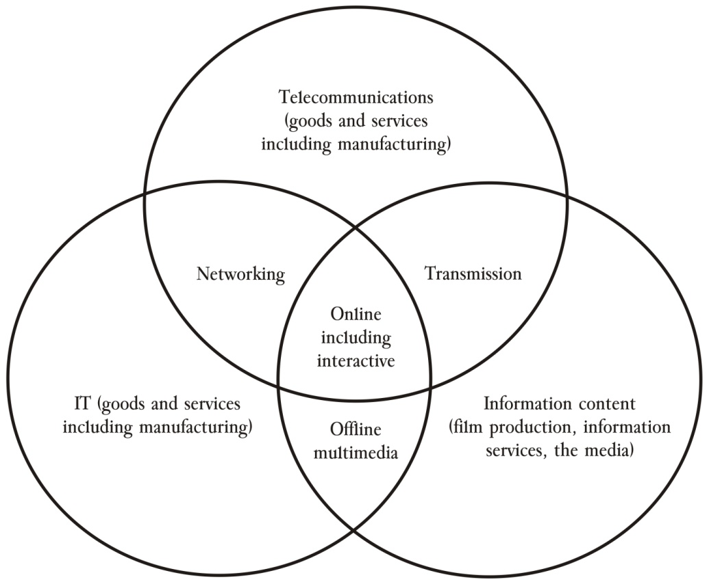
Source: D’Costa, 2006.

1. Telecommunications
Telecoms industry has experienced rapid growth in Pakistan, which has been an outstanding performer in terms of growth in telecoms worldwide. Tele-density in 2007 was 47%, which was much greater than all of its neighbors (PTA Annual Report 2007 www.pta.gov.pk). Network coverage was 90% of the population and there were 77 million mobile phone subscribers. During the last 4 years (i.e., 2003-04 to 2006-07), investment in telecom sector in Pakistan was over $ 8 billion (about 12% of the total private investment during this period) of that over $ 4 billion was in the form of FDI (about 40% of the total FDI during this period). In terms of employment generation, 1.4 million people were employed, directly or indirectly, in this sector, which is about 7% of the total non-agricultural employment in the country. This figure includes the 0.5 million people employed through Public Call Offices and another 0.4 million people working in sales and franchise. Total revenue of the telecom Industry was Rs. 236 billion in 2006-07, and the total taxes paid were Rs. 100 billion, which was 11% of the government’s total tax revenue. In brief the telecoms industry in Pakistan has expanded rapidly in recent years and is now an important sector of the economy. There is great potential for continued expansion in number of users as well as in growth of value added services such as mobile internet and other data services, local content and information services, and mobile banking services.
2. Information Technology (IT)
According to the official balance of payments data, Pakistan had $150 million of exports in IT services in 2005-06. However, the official figures do not utilize the standard WTO methodology for calculating trade in services. India has adopted the WTO methodology for calculating exports of IT services, which not only adds the amount of services shipped abroad, but also the revenues of Indian companies and IT professionals that are based abroad. Using the WTO methodology for calculating trade in services, Pakistan IT export revenues were about $1 billion in 2005-06, and the total global revenue of IT industry were about $2.2 billion (Hussain, 2006). These figures seem quite reasonable, if we compare some of the key ratios between Pakistan and India. The above numbers imply a ratio between Pakistan and India for global IT revenue of 1:18 (1:38 for exports and 1:10 for domestic revenue); while in terms of IT personnel the ratio between Pakistan and India is 1:13 to 1:18 (estimates for IT professionals in Pakistan range from 54,000 to 75,000 compared with 965,000 in India), and the ratio for bandwidth usage was 1:10 (ibid). The direct contribution of the IT sector to the economy was about $1.5 billion in 2005-06 (direct exports of $150 million and domestic revenue of $1.35 billion), i.e. over 1% of the GNP.
Pakistan is considered one of the leaders in the second tier countries in the global ICT industry. Pakistan’s poor international image is a huge impediment for realizing its true potential in this industry. Other than that, Pakistan has more or less similar endowments, in terms of human resources, culture and language skills, as India. Thus Pakistan could become a major center for outsourcing purposes, if it could use its neighborhood advantage to leverage of India’s position as the leader in the field of IT outsourcing. The “Flying Geese” model, which worked so well in the East and Southeast Asia for spread of export industry from one country to another in the region, can be replicated in South Asia with IT outsourcing export industry spreading from India to other countries in the region. The development of the IT sector in India would have spillover effects to the other economies in the region. As the costs in the IT sector rise in established centers in India, firms look for less expensive locations and hence are moving into the smaller cities within India. However, if conditions permitted they could as easily move to locations in Pakistan (this we refer to as the neighborhood effect), but current restrictions on investment and trade prevent Indian IT firms from locating in Pakistan. Pakistan could get around the ‘poor image’ issue by forming joint ventures with Indian firms, who have the expertise and market connections. Also, management in the IT sector is a skill that has to be learnt, and Indian firms have developed the skills to run call centers employing large numbers of persons and the transfer of such management skills to local firms could be another spillover from such arrangements. Thus opening up investment and trade with India in the IT sector could help Pakistan establish itself as a global force in this sector.
3. Information Content
Pakistan is going through a media revolution. There are now 70 private satellite TV channels and 74 private FM radio stations, and new ones are being added every day. There are 350 newspaper dailies, and 560 magazines. There are 1600 licensed cable operators, and 3.5 million cable subscribers. It is reported that GEO TV has 10 million viewers, and the revenue of electronic media industry is over Rs. 8 billion (Planning Commission, 2008). Investment in satellite and cable industry is over Rs. 10 billion, and another Rs. 10 billion has been invested in the print media. In terms of content, there is great diversity and, while the quality is uneven, it has a large international market among the Pakistani Diaspora and in some areas such as pop music it is competitive even in a wider international market. In brief, the information content industry has also grown rapidly and, while it may not be as competitive as India, it has the potential to be an important source of employment and even service exports.
Thus we can see that in recent years, Pakistan has done extremely well in all sectors of the “new knowledge economy”. Moreover, it is evident that Pakistan has considerable potential in these areas and with the right policies they could continue to expand rapidly. It is important to realize that, as stated earlier, these sectors are likely to be the key to international competitiveness and productivity growth in the future and have the potential to be an important driver of economic growth in Pakistan. It is necessary to recognize this, and not to see these activities as merely consumption – and luxury consumption at that – to be throttled by excessive taxation as is being done currently.
B. Agriculture Biotechnologies – The Next Green Revolution
Pakistan with the largest contiguous canal irrigation system in the world, diversity of climatic zones, rich soils and centuries of farming tradition has considerable competitive advantage in agriculture. Most of Pakistan’s exports are directly or indirectly based on agriculture, e.g., rice, cotton textiles, leather and leather products, fruits and processed food products. Pakistan is also one of the largest milk producers in the world. This is despite the fact that crop and milk yields are among the lowest in the world. These two contrasting realities are an indicator of the huge potential of agriculture sector as a driver of growth in Pakistan. The new agriculture biotechnologies have made it possible for Pakistan to realize this potential because of the possibility of a quantum jump in yields across a broad range of crops and livestock. With a large majority of the population dependent directly or indirectly on agriculture, including livestock, and the high levels of poverty in rural areas, accelerating agriculture growth is likely to have a greater impact on incomes and poverty in Pakistan than any other sector. Below we discuss the experience of Bt cotton in India and hybrid maize in Pakistan to show what is possible with the available biotechnologies and the right policies.
In 1998, Monsanto was negotiating with the Government for the introduction of genetically engineered cotton seeds in Pakistan. The new Government in 1999 abandoned these plans, not because of any ethical or environmental concerns, but because the bureaucracy convinced the decision makers that these seeds should be developed by the public sector. The argument ran along the usual lines, that the foreign multinational corporation will exploit the poor farmers by providing seeds for a vital crop such as cotton at exorbitant prices. Moreover, there is not much to the technology and it can be cheaply developed in the public sector and Bt seeds can be made available to the poor farmers at a nominal cost. As a result, Bt cotton seeds are still not available to farmers in Pakistan and cotton production is stagnating while farmers have to spend huge amounts on pesticides to barely maintain past yields.
In contrast, in India Monsanto’s Bt cotton seeds were approved for cultivation in 2002. In 5 years cotton production in India increased from less than 15 million bales to over 27 million bales, with yields increasing by about 60%. The farmers in India are also using less pesticides because of the built in pest resistance of Bt cotton seeds, and apparently even the quality of the fiber is better since it does not suffer from pest damage. Thus in five years, India has gone from being one of the largest importers of cotton to an exporter. Pakistani farmers are, however, using Bt cotton seeds smuggled from India which are not necessarily suited for agriculture conditions in Pakistan. Thus Pakistani farmers are paying the higher prices, but not the getting the full benefits of Bt cotton seeds.
The other story is a happier one. Hybrid maize varieties were introduced in Pakistan in the 1990s by a multinational corporation. The government did not interfere because it did not consider maize to be a vital crop like cotton. As a result maize production in irrigated Punjab increased from 0.75 million tons in 1999-2000 to 2.26 tons in 2005-06, i.e., by over 200%, while yields increased by over 100%. In brief there has been a revolution in maize production in the last decade because of biotechnologies, but not many people have heard of it.
There are several lessons from these two contrasting stories. First, as most agriculturists’ know, in Pakistan the Government and the bureaucracy are the problem rather than the solution. Second, the international seed companies have the knowledge of agriculture biotechnologies and the experience to distribute them in developing countries. They don’t force farmers to buy their seeds, and if the seeds don’t give value for money they will not be able to sell them. Therefore, the role of the Government should be to provide a supportive policy and regulatory framework for encouraging international seed companies to set up operations in Pakistan. As a regulator, the Government’s role should be to ensure observance of quality, environmental, safety and health standards on the one hand, and safeguard the intellectual property rights of the seed companies on the other.
Besides this, as far as agriculture is concerned, the Government should concentrate on building and maintaining rural and irrigation infrastructure, modernizing agriculture marketing regulations and market infrastructure, and investing in human development in rural areas. It is evident that with the right policies and equitable investment – agriculture contributes over 20% to the GDP, but receives hardly 5% of the public investment – in rural infrastructure and human development, a biotechnology led revolution in agriculture is possible and that should be one of the pillars of Pakistan’s development strategy.
C. Modern Retailing – Linking Agriculture to World Markets
Globalization has many implications, but one that I want to discuss is the growth of modern retailing, i.e., supermarkets. Starting in the 1990s, there has been a phenomenal expansion of supermarkets in developing countries (Reardon and Berdegue, 2006). A key factor in this rapid growth has been FDI. The dominant players in FDI are five companies, Carrefour, Wal-Mart, Ahold, Metro and Tesco, which together have $600 billion in sales. Out of these, Metro already has supermarkets in Karachi, Lahore and Islamabad, and Carrefour has announced plans to open stores in Pakistan. These global players not only aim to expand their retailing activities in the developing countries, but also integrate these countries into their global supply chain.
The spread of supermarkets has taken place in waves, with India being a third-wave country with the process starting in 2004 and Pakistan seems to be part of the fourth emerging wave. In the second-wave countries, the supermarkets’ share of the retail market went from 5-10% in 1990 to 30-50% in early 2000s (ibid). Figure 2, which plots the share of supermarkets in retail food against the level income of a country, shows that the share rises very sharply between incomes of 2000 and 5000 Purchasing Power Parity (PPP) dollars. Pakistan’s per capita GDP today is around 2500 PPP dollars and on that basis, according to the fitted curve, supermarkets should account for about 20% of the retail food trade, but currently their share in Pakistan is almost negligible. What that means is that once supermarkets begin to expand in Pakistan, there share will increase rapidly and one can expect that by 2015 supermarkets will be major players in the retail market in the country.
Figure-2: Spread of Supermarkets and Income Levels
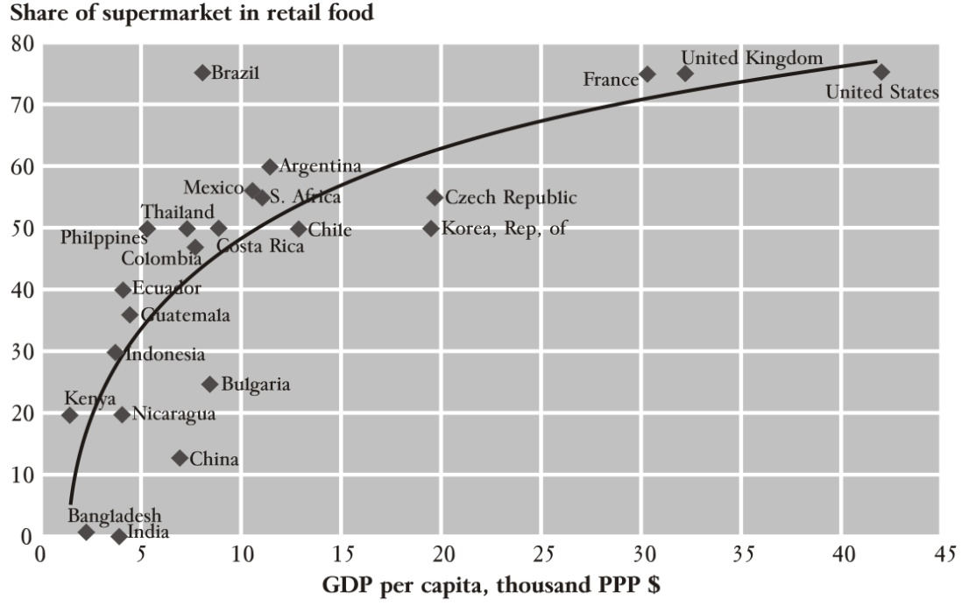
Source: World Development Report 2008
The expansion of supermarkets is likely to have a major impact on the agricultural marketing system in Pakistan. The current system is primitive and the key players haven’t changed in almost a hundred years – agricultural markets in the Punjab are still governed by the 1930s Agricultural Marketing Act. The system is highly fragmented and monopolistic, with many layers of relatively small operators. The structure of agents, arthis, and market committees is repeated at the level of small market towns and large city markets with commissions and fees being added at each stage. There is often a huge gap between farm gate and retail prices for perishables – at times it can be as much as a 100% - and there is a tremendous amount of waste and inefficiency. The first impact of the growth of supermarkets is the development of modern procurement systems, with wholesalers and associated infrastructure, such as warehouses, cold chains and logistics, and the establishment of grades and standards. As a result there are large system efficiency gains, and a reduction in the wedge between producer and retail prices. Thus both farmers and consumers benefit. Also the wholesalers establish links with farmers, making them more responsive to changing demands and conscious of quality and other standards. Thus leading to higher value added agricultural production.
In addition to backward linkages, supermarkets are also part of the global supply chains and procure on behalf of their sister stores in other countries. Thus once production in Pakistan begins to meet international quality and quantity requirements, they will begin to supply some agriculture products to stores in other countries from Pakistan. Thus Metro Pakistan may supply kinoos, mangoes, basmati rice, prawns, etc., to Metro stores in Russia or Turkey, just as it might get lentils, olives, etc., from there for its stores in Pakistan. Thus high value agriculture for international markets will be promoted in Pakistan.
Therefore, it is important to support the growth of modern retailing in Pakistan through appropriate policies and, where necessary, investment in infrastructure. However, at the same time it is important to assist small farmers by facilitating the formation of marketing cooperatives so that they too can fully benefit from the higher prices and the expanding market for high value agricultural products. Similarly, small shopkeepers in big cities may need support as they are likely to be most affected by increased competition from the expansion of supermarkets.
IV. Conclusion
The main components of the proposed development strategy are the knowledge economy, biotechnology driven agriculture growth and strong support for development of a modern retailing sector. There are obvious linkages between these three, but more important are the linkages between them and other growth areas in the economy. For example, expansion of supermarkets in Pakistan will not only help the agriculture sector link into global supply claims, but it will also facilitate the development of such linkages for the export oriented manufacturing sector. Moreover, investments needed to support these drivers of growth will also benefit other sectors, and may open up new internationally competitive avenues. These sectors need investment and policies supporting education and human development, agriculture research, and science and technology, which can open up the possibilities of developing export-oriented higher education and medical services capability. For export oriented agriculture sector to succeed the current anti-export bias of macro policy, particularly exchange rate policy, will have to be neutralized, which in turn will also benefit export oriented manufacturing, as well as tradable production for the domestic economy.
Besides, macro and sectoral policy changes, there will be a need to restructure the public sector development program. Fortunately, a large part of the infrastructure investment requirements of the selected sectors, such as in fiber optic cables, broadband connectivity, international gateways and uplink facilities, supermarkets infrastructure, etc., will be met by the private sector itself, provided a supportive policy framework is in place. However, public investment in the soft sectors, particularly education, and in improving the quality of urban infrastructure will need to be greatly increased. The latter is necessary because livable cities are essential for the successful development of a high value services-export sector.
To conclude, the potential and opportunities are there for Pakistan to achieve sustained high growth. Hopefully, this paper provides a rough sketch of a development strategy that can help Pakistan to do this. However, since these ideas are different from the usual manufacturing focused development strategy approach, they may be difficult to accept. To traditional economists, I would like to say that in this strategy I am not suggesting that there is no role for the manufacturing sector but only that the drivers of the proposed strategy are different. In pursuing this strategy we will also create an economic environment in which the manufacturing sector will flourish. However, there is a need to alter the focus because in a development strategy which starts with the manufacturing sector, the drivers identified above are likely to be neglected, but if the proposed strategy is adopted, the manufacturing sector will not suffer because of neglect.
References

D’Costa, A. P., 2006, The New Economy in Development: ICT Challenges and Opportunities, Palgrave Macmillan.
Hamid, Naved, 2007, “A Development Strategy for the Information Age. Asian Development Bank,” Report on the South Asia Department Economists' Annual Conference, pages 7-16.

Haq, Mahbub ul, 1966, The Strategy of Economic Planning: A Case Study of Pakistan, Karachi: Pakistan Branch, Oxford University Press, 1966.
Hussain, Yusaf, 2006, Pakistan’s IT Revenue May be Grossly Understated. Pakistan Software Export Board (PSEB), http://www.pseb.org.pk/ UserFiles/documents/IT_Revenue_Understated_V1.4.pdf.
Pakistan Telecommunication Authority (PTA), 2007, Annual Report 2007, Islamabad, Pakistan http://www.pta.gov.pk/annual-reports/ annrep0607/contents.pdf.
Planning Commission, 2008, Annual Plan 2007-08, Government of Pakistan, Islamabad, Pakistan.

Reardon, Thomas, and Julio A. Berdegue, 2006, “The Retail-led Transformation of Agrifood Systems and its Implications for Development Polices.” Rimisp-Latin American Center for Rural Development. http://www.rimisp.org/getdoc.php?docid=6432.
Rodrik, Dani, 2006, “Goodbye Washington Concensus, Hello Washington Confusion?" Journal of Economic Literature: 44 (2006): 973-87.
Rostow, W. W., 1960, The Stages of Economic Growth: A Non-Communist
Manifesto. Cambridge University Press, Cambridge, UK.
World Bank, 2005, Economic Growth in the 1990s: Learning from a Decade of Reform, Washington DC.
World Bank, 2008, Agriculture for Development, World Development Report, Washington DC.

 Director, Centre for Research in Economics & Business (CREB), Lahore School of Economics. I want to acknowledge the excellent assistance of Mr. Muhammad Aqeel Akbar Chaudhry (Lahore School of Economics) in the preparation of this paper.

